DRAFT memorandum
to: | Norwich Selectboard, Norwich Planning Commission
from: | Norwich Trails Committee
subject: | Overview of Norwich Trails Committee and its volunteers
date: | April X, 2022
cc: | Town Manager, Town Planner
- Summary – This memo summarizes the role of the Norwich Trails Committee and its volunteers and lays out the aspects of the town’s trail network that require the awareness of the selectboard to properly fund their upkeep, maintain their integrity, and provide for the public’s beneficial use. This information provides context to the annual budgetary requests of the Norwich Conservation Commission—which advocates for the town’s trail system across public and private lands.
- Introduction – Norwich Trails volunteers work with landowners and cooperating organizations to maintain a network of public trails, spanning Norwich and interconnecting with neighboring communities under the direction of the Norwich Trails Committee (NTC), which meets with them on the first Wednesday of each month.
The volunteers maintain the Norwich Trails website at https://norwichtrails.org, which offers downloadable trail maps and news about activities, including the monthly committee meetings.
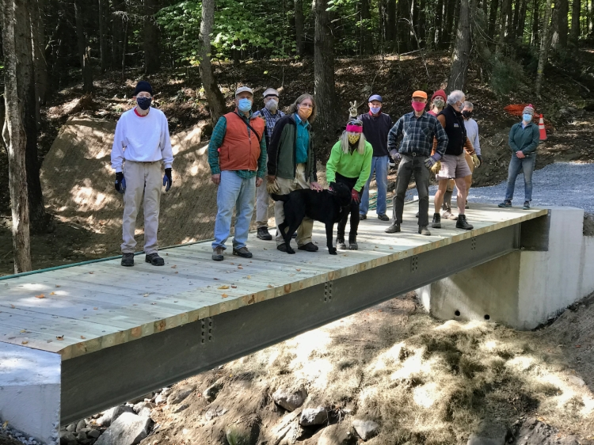
Trails volunteers after installing erosion control at the Brown Schoolhouse Bridge
- Trails network – There are about 37 miles of publicly accessible trails that the Norwich Trails volunteers and their partners maintain. Two major systems are situated on either side of Beaver Meadow Road, which are served by the Parcel 5 parking lot and connected by the new bridge over the Charles Brown Brook. Principal among these are the Gile Mountain Trail, Bill Ballard Trail, Parcel 5 Trails, and the Appalachian Trail.
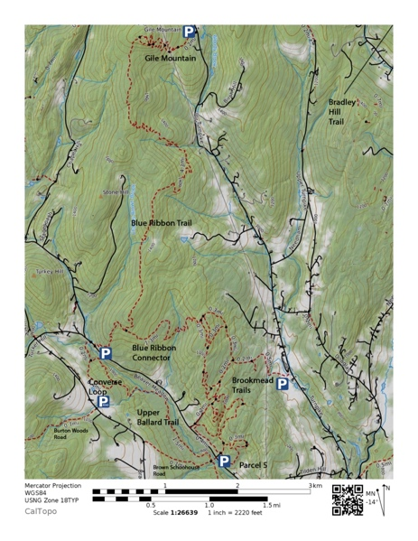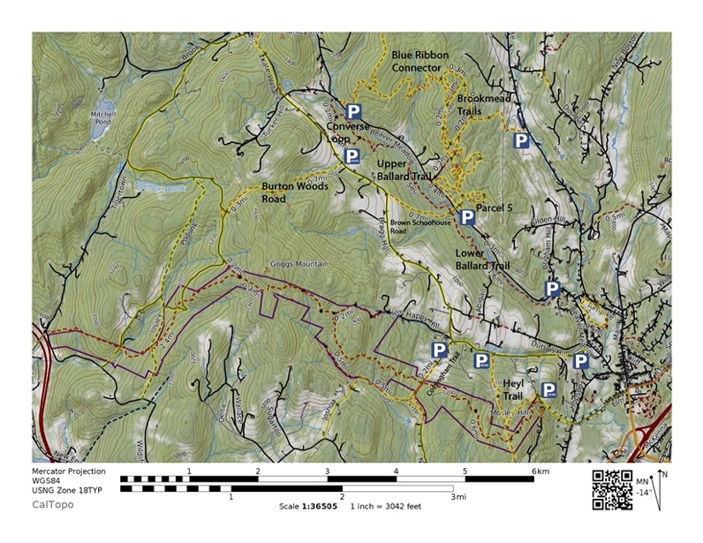
Norwich trail networks: north and south of Beaver Meadow Road (left and right)
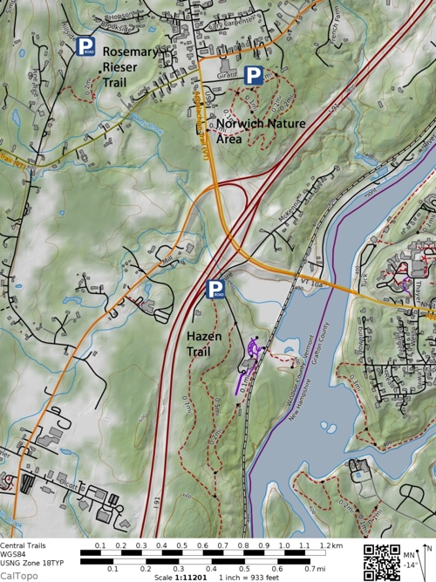
Eastern trails, near downtown
The trails cross multiple jurisdictions on land owned by:
- Town of Norwich: Gile Mountain, Blue Ribbon Trail, Schmidt Bog, Norwich Nature Area, Bradley Hill, Heyl, Cossingham, Burton Woods, Woods Road Trail, Powers Trail, TH 51, and other class IV road segments
- Norwich Fire district: Ballard, Parcel 5, and Blue Ribbon Connector
- Federal government: Appalachian, and Tucker
- Private landowners: portion of Ballard and Blue Ribbon, Brookmead, Hazen, King Arthur, and Rieser
Most of these trails interconnect and are enjoyed by the public as part of the amenities that make Norwich attractive to its residents.
In addition, there are many privately held and maintained trail networks in town that are not shown on the Norwich Trails website, unless requested by the landowners.
Under discussion at times, has been the possibility of a trail that would pass across private property from Huntley Meadow to the Dresden playing fields. Such a core trail would have to be assembled piecemeal with landowner cooperation.
- Governance – The Norwich Trails Committee is a three-member subcommittee of the Norwich Conservation Commission (NCC). It oversees the activities of the Norwich Trails volunteers, who maintain trails in our town. The NTC reports to the Norwich selectboard and town manager through the NCC and its chair.
The NTC coordinates town-funded and grant-funded projects through the town manager, in coordination with the Finance Department. Any NTC member may be designated to coordinate individual initiatives, according to the consensus of the committee in a warned meeting.
Norwich Trails volunteers seek reimbursement of any authorized out-of-pocket expenditures that they may have, through a designated NTC member.
The NTC coordinates prospective trail work with the Upper Valley Trails Alliance (UVTA)—to which organization the town votes funds in a separate warrant article—to provide expert advice and to oversee the efforts of cadres of volunteers from local companies and youth groups that complement the efforts of Norwich Trails volunteers.
The Norwich Trails website is privately funded, as of 2022, and not subject to town governance. The volunteers, who maintain this website, are open to closer coordination with the town.
- Budgeting – Much of the input into trail maintenance and infrastructure improvement is through volunteer labor. A certain amount of the effort is unplanned, owing to downed trees or storm events. Another class of effort is planned upkeep and maintenance of trail infrastructure. The unplanned activities require a baseline annual funding line for material expenses. The planned activities are subject to funding through town and grant sources. The NTC has been successful in soliciting grants for such improvements as bridge replacement, trail signage, and treadway restoration. Nonetheless, capital expenditures on town land should be supported by taxpayer funds, when necessary.
For capital projects, the NTC has applied to the Vermont Recreational Trails Program (RTP) for matching funding. Such funding was instrumental to the infrastructure improvements on Gile Mountain. Unfortunately, it was not available for the Brown Schoolhouse Bridge project because the funding committee decided that prior-year applicants would be funded, instead. The Jack and Dorothy Byrne Foundation was a generous contributor towards the bridge project.
- Town-owned trail infrastructure – Each of the trails on town-owned land or rights of way has infrastructure investments that have a finite lifetime, require annual maintenance, or are vulnerable to weather extremes. Here are trail infrastructure items that may require budgeting attention in upcoming years:
- Gile Mountain: The trail received a substantial improvement in drainage and treadway with stone steps that were installed with the help of RTP funding. These require annual maintenance of the drainage after the leaves are down. Segments of the treadway are supported by wooden cribbing for steps and sidewall support, which have a finite life. The wooden steps on the fire tower observation platform will require replacement, sometime. The remains of the cabin have been an attractive nuisance for vandals, at times. It may require removal at some point.
As Norwich’s most-visited trail, the trailhead parking lot has had insufficient capacity at times. A scoping study was budgeted for FY 2022-3 to identify a solution to this problem.
- Ballard Trail: This trail runs along the Charles Brown Brook and has three trailheads—at Ballard Park, at the Brown Schoolhouse Bridge, and near the intersection of Tucker Hill Road with Beaver Meadow Road. The trail crosses many tributaries to the brook, some requiring a few stepping stones to cross, others with wooden bridges, and still others with bog bridges. As of 2022, the bridges and bog bridges will be in a new 10 to 15-year replacement cycle.
Segments of the trail are vulnerable to flooding events that have necessitated importation of fill material to restore the treadway. One segment was subject to a landslide that necessitated a trail relocation up and down a steep pitch, using stone steps. Much of the soil along the trail is clay-rich and subject to progressive erosion.
The Brown Schoolhouse Bridge was completed in 2020, thanks to a town warrant article. It’s constructed with concrete abutments, galvanized steel beams, a thick wooden deck, and aluminum railings, all with long life spans. The deck may require replacement sometime after 2050.
A segment of the Ballard Trail crosses the private property of a cooperating landowner. If a permanent ROW doesn’t yet exist, one should be acquired to assure the continued use of this popular trail.
- Schmidt Bog: This bog is a town-owned 22.5-acre natural area, accessible from Upper Loveland Road. It was acquired for preservation with the advocacy of Bill Ballard, because of its habitat for lady slippers and other bog species. It features a board walk, which is visited by school groups. As of 2022, the boardwalk was to be assessed for maintenance or replacement. Lacking also are trailhead information and interpretive signage.
- Burton Woods Road: This class IV road passes from Bragg Hill to Podunk Road over the ridge of Griggs Mountain. At the Bragg Hill end, a beaver pond prevents passage of motorized traffic, except in winter. The segment between the pond and the ridge has been subject to severe erosion from the passage of trucks that come to the dead end and turn around. This segment is a candidate for load restrictions that permit the passage of ATVs and snow machines, but exclude trucks and forest machinery (except with a permit) to allow water bars to be constructed and maintained. Their construction might require contracted mechanical equipment.
- Bradley Hill Road: The upper end of the trail has, at times, been relocated onto private property because of trees falling across the right of way (ROW). The ROW is a candidate for permanent improvement of the treadway to address drainage. The northern end of the trail at Kerwin Hill Road has been subject to severe erosion that has necessitated relocation at that point.
- Powers Trail: This class IV road is a wet, washed-out connection that completes a loop via Kerwin Hill and Pattrell Roads. It would benefit from improved drainage to create a treadway. This construction might require contracted mechanical equipment.
- Heyl Trail: This town ROW roughly parallels the Appalachian Trail from the top of Elm Street to the VELCO power line; it then turns north to Bragg Hill Road along the power line ROW. A recently installed bog bridge at the Elm Street end has approximately 10-15 years of life from its installation in 2020. The trail has insufficient and ill-defined parking at both ends.
- Woods Road Trail: This trail starts on the Gile Mountain Trail, goes downhill beside the VELCO ROW along the eastern edge of the Woody Adams Conservation Forest and ends at Turnpike Rd. It has major drainage issues, which will require gating, water bars, grading, and two small stream crossings.
- Parking –Construction and maintenance of parking areas at trailheads are the responsibility of the Department of Public Works. The town maintains off-road parking at Ballard Park, Parcel 5, upper trailhead to the Ballard Trail, Gile Mountain, and Cossingham Road. There is ill-defined parking at turn-around locations at Happy Hill, Upper Loveland, and Bradley Hill—these areas require clear delineation of where parking is permitted in all seasons. Other trailhead locations have roadside parking (Hazen, Heyl at both ends, Burton Woods, and upper Brown Schoolhouse), where winter maintenance may not push far enough onto the shoulder to facilitate parking out of the roadway and out of the possible path of maintenance and emergency vehicles. Most Norwich trails have substantial hiking and skiing traffic in winter.
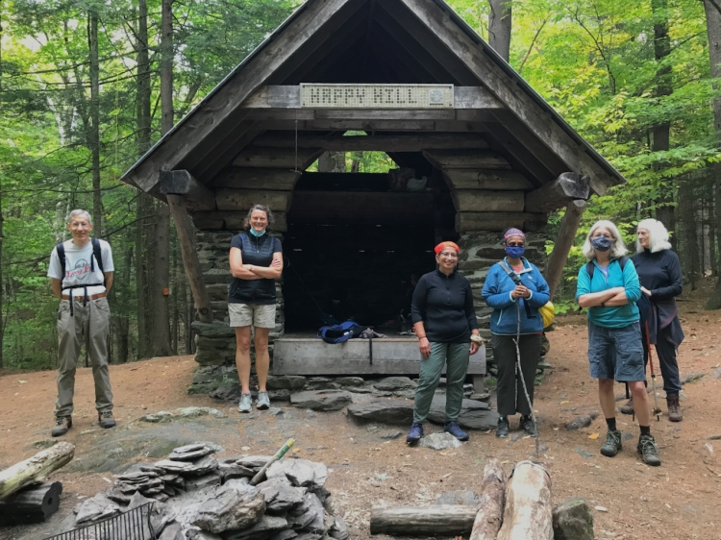
“Discovery hike” to Happy Hill shelter on the Appalachian Trail, guided by Norwich volunteers

