DRAFT memorandum
to: | Norwich Selectboard
from: | Norwich Trails Committee
subject: | Request: Establish load limits on Burton Woods Road
date: | March X, 2022
cc: | Nick Krembs, Stephen Flanders, Liz Burdette (UVMBA Chairperson)
- Request – The Norwich Trails Committee requests that the selectboard lower the load limits on the portion of Burton Woods Road between Bragg Hill Road and the ridge of Griggs Mountain to allow use by off-road vehicles of up to 1,200 lbs. and require a written permit for passage by heavier vehicles, contingent on repair of any damage to the drainage in the right of way. The western side of the ridge would remain open to motorized traffic, without constraint. Signage, combined with physical impediments would exclude non-conforming vehicles.
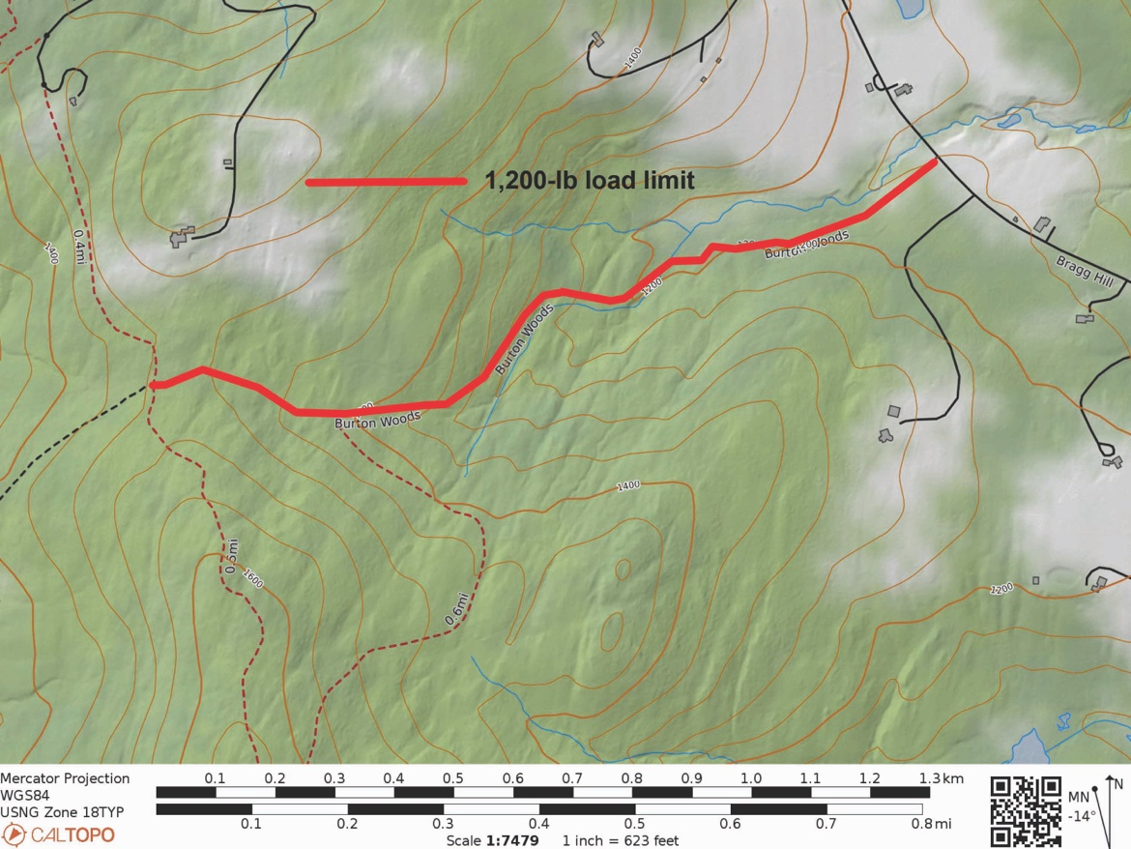
Site of proposed load limit restriction from Bragg Hill to the ridge of Griggs Mountain
- Justification – The right of way (ROW) is steep and wet. Occasional recreational vehicle traffic exacerbates the erosion and prevents mitigation of damage. Lower load limits will allow implementation of sustainable erosion control measures that will greatly increase the usefulness of the trail to all trail users, whether on foot or off-road vehicles. Damage details are in the Image Gallery.
- Abutters –There are five abutting properties to the section of ROW proposed for conversion:
- South side: Susan F. McLaughry Revokable Trust, 1093 Bragg Hill Road.
- South side, near ridge: Upper Valley Land Trust, 19 Buck Road, Hanover, NH 03755
- North side, on Bragg Hill Road: Catherine Spencer, 1141 Bragg Hill Road.
- North side, west of Spencer to the ridge: Benjamin and Christianna Morley, 1219 Bragg Hill Rd.
- North side, Morley to ridge: Shonda Rhimes, Los Angeles, CA.
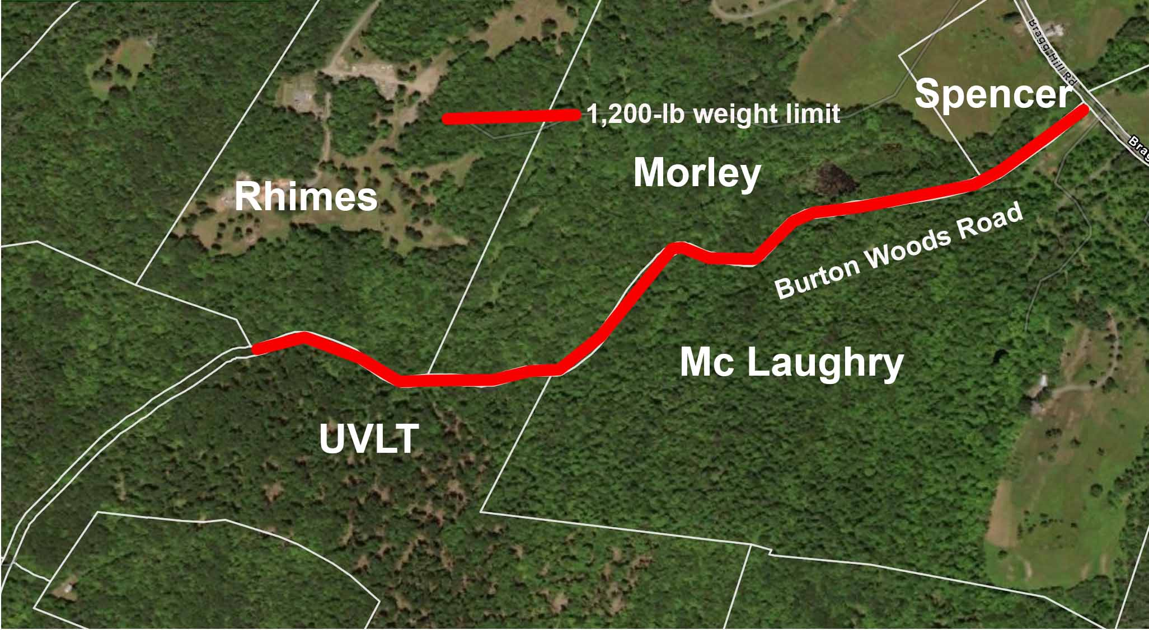
Parcels adjacent to proposed trail conversion
- Impact –Lowering the load limits would have the following considerations:
- The section does not connect to properties requiring motor vehicle access.
- It is part of a variety of loops that serve cyclists and hikers.
- The road beyond the west side of the trail serves several camps, which gain access from Tigertown Road and would be unaffected by the lowered limits.
- It would allow sustainable erosion control measures that would benefit all users, whether on foot or on off-road vehicles.
- Forestry operations using the ROW would be subject to a permit that could require repairing any damage to drainage structures.
- Statute – 19 V.S.A. § 303 gives the selectboard the authority to regulate town roads. 19 V.S.A. § 304 grants the selectboard the power to “See that town highways and bridges are properly laid out, constructed, maintained, altered, widened, vacated, discontinued, and operated, when the safety of the public requires, in accordance with the provisions of this title.” 19 V.S.A. § 1111 gives towns to require permits in ROWs.
- VLCT Guidance – The Vermont League of Cities and Towns MODEL CLASS 4 HIGHWAY POLICY AND GUIDANCE says, “The Selectboard shall exercise control of class 4 highways to ensure their integrity as public rights-of-way by means which may include, but are not limited to, the following:”
- Establishment of vehicle weight limits;
- Prohibition or restriction of use by motorized vehicles;
- Imposition of requirements for temporary permit for heavy equipment access which may include a stipulation that any highway damaged will be repaired by or at the expense of the user, or posting of bond or other security to guarantee that repairs are made; either or both of which may be required as a condition of any permits;
- Granting permission to pent (gate) a Town highway.
- Draft motion – “… to amend § 103-13 (Page 44) of the town code to add “D. The load limit for vehicles on Burton Woods Road shall be 1,200 lbs between Bragg Hill Road and the highest point of the road. The Town Manager shall require prior written permission for vehicles over 1,200 lbs, subject to a requirement to repair any damaged caused. The Town Manager shall be authorized to place and maintain physical impediments to non-conforming vehicles.”
Image Gallery
Images were shot on 20 June 2021 during semi-drought conditions.
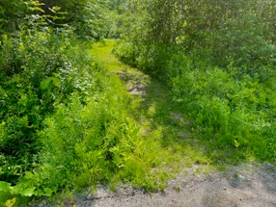  Entry from Bragg Hill Road is narrower than a vehicle | 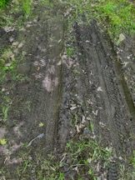  Traffic observed was mostly mountain bikes.
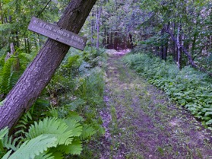  Lower section is normally poorly drained. | 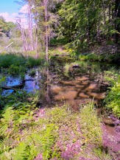  The ROW passes through a beaver pond.
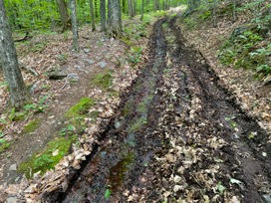  Multiple sections of ROW are wet and drain through tire ruts. | 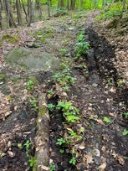  Steep, rocky sections compromise vehicle passage.
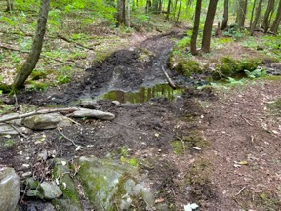  This stream crossing near the ridge is usually much wetter. | 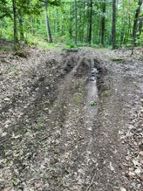  The junction at the top proposed weight-restricted road segment
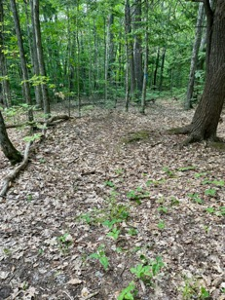  The trail leading south at the junction | 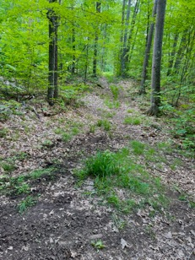  The trail leading north at the junction

