DRAFT memorandum
to: | Norwich Selectboard
from: | Norwich Trails Committee
subject: | Request: Reclassify portion of Burton Woods Road as Trail
date: | October 8, 2021
cc: | Nick Krembs, Stephen Flanders, Liz Burdette (UVMBA Chairperson)
- Request – The Norwich Trails Committee requests that the selectboard change the classification of the portion of Burton Woods Road between Bragg Hill Road and the ridge of Griggs Mountain from “Fourth-Class Road”, which allows the use of all motorized vehicles, to “Trail”, which would allow use by off-road vehicles of up to 1,200 lbs, but require a written permit for passage by heavier vehicles, contingent on repair of any damage to the drainage in the right of way. The western side of the ridge would remain open to motorized traffic, without constraint.
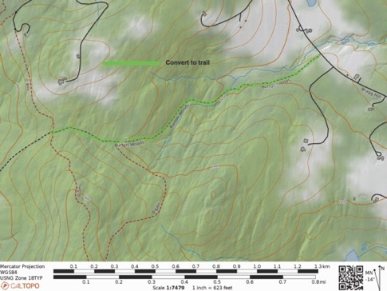
Site of proposed conversion to trail from Bragg Hill to the ridge of Griggs Mountain
- Justification – The right of way (ROW) is steep and wet. Occasional recreational vehicle traffic exacerbates the erosion and prevents mitigation of damage. Conversion to a trail will allow implementation of sustainable erosion control measures that will greatly increase the usefulness of the trail to cyclists and hikers. More details are described in the Image Gallery.
- Abutters –There are four abutting properties to the section of ROW proposed for conversion:
- South side: Susan F. McLaughry Revokable Trust, 1093 Bragg Hill Road.
- South side, near ridge: Upper Valley Land Trust, 19 Buck Road, Hanover, NH 03755
- North side, on Bragg Hill Road: Catherine Spencer, 1141 Bragg Hill Road.
- North side, west of Spencer to the ridge: Benjamin and Christianna Morley, 1219 Bragg Hill Road.
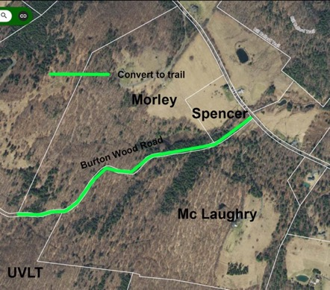
Parcels adjacent to proposed trail conversion
- Impact –Conversion to a trail would have the following effects.
- The section does not connect to properties requiring motor vehicle access.
- It is part of a variety of loops that serve cyclists and hikers.
- The road beyond the west side of the trail serves several camps, which gain access from Tigertown Road and would be unaffected by the conversion.
- It would allow sustainable erosion control measures that would benefit cyclists and hikers.
- Forestry operations using the ROW would be subject to a permit that could require repairing any damage to drainage structures.
- Statute – 19 V.S.A. § 304 grants the selectboard the power to “lay out, alter, classify, and discontinue town highways”. 19 V.S.A. § 708 (a) allows the selectboard to initiate laying out, altering, reclassifying, or discontinuing highways on its own. 19 V.S.A. § 709 requires the board to:
- Appoint a time and date both for examining the premises and hearing the persons interested.
- Give 30 days' notice to the petitioners, and to persons owning or interested in lands through which the highway may pass or abut, of the time when they will inspect the site and receive testimony.
- Give notice to any municipal planning commission in the town, post a copy of the notice in the office of the town clerk, and cause a notice to be published in a local newspaper of general circulation in the area not less than ten days before the time set for the hearing.
- Give notice by certified mail sent to the official residence of the person(s) required to be notified.
- Ordinance – The Norwich ordinance relating to use of trails says:
- Trail rights of way may be used for hiking, walking, bicycling, cross-country skiing, snowmobiling, horseback riding and other similar activities all at the risk of the user.
- The operation of a motor vehicle is prohibited on any Trail, as defined herein, unless the operator of the motor vehicle has a valid permit issued by the Norwich Selectboard.
- No person may alter or injure the right of way of any Trail by obstructing or diverting a stream, water course or sluice, or by dragging logs or timber or any other objects within the right of way or cutting brush or trees, or altering drainage or grades and slopes, or any other modifications within the Trail right of way without first having received a permit from the Selectboard.
- Draft motion – “… to initiate re-classification of the portion of Burton Woods Road from Bragg Hill Road to the crest of the ridge of Griggs Mountain from “Fourth-Class Road” to “Trail” open to motorized vehicles of 1,200 lbs or less and requiring a written permit from the town manager for vehicles of 1,200 lbs or more to be subject to a requirement to repair damage to drainage structures, to be named “Burton Woods Trail”, pursuant to the authority granted by 19 V.S.A. § 708 (a) and after completing the steps required by 19 V.S.A. § 709.”
Image Gallery
Images were shot on 20 June 2021 during semi-drought conditions.
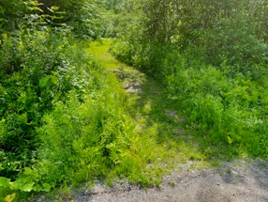  Entry from Bragg Hill Road is narrower than a vehicle | 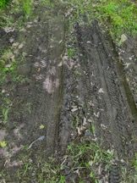  Traffic observed was mostly mountain bikes.
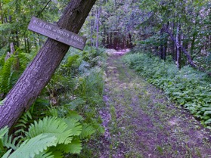  Lower section is normally poorly drained. | 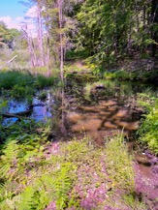  The “road” passes through a beaver pond.
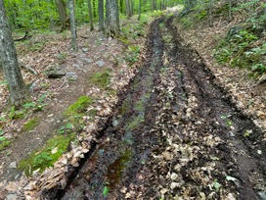  Multiple sections of ROW are wet and drain through tire ruts. | 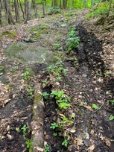  Steep, rocky sections compromise vehicle passage.
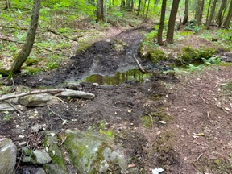  This stream crossing near the ridge is usually much wetter. | 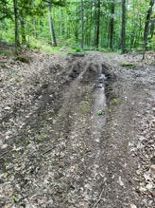  The junction at the top of the proposed re-classification
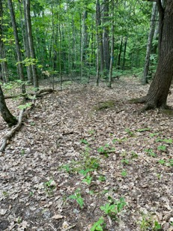  The trail leading south at the junction | 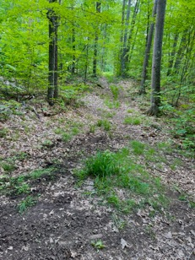  The trail leading north at the junction
Appendix to Memo
From: Patricia Derrick <derrickpt@aol.com>
Subject: Re: Update on Burton Woods Right of Way
Date: September 27, 2021 at 7:16:42 PM EDT
To: "norwichtrailsignup@gmail.com" <norwichtrailsignup@gmail.com>
Cc: "craig.d.layne@gmail.com" <craig.d.layne@gmail.com>
Thank you Mr. Flanders for the updated proposal regarding the reclassification of a portion of Burton Woods Road.
We continue to object to excluding the public from the use of town roads. The roads were built for the use by all. They should not be exclusive to a few who have qualifying vehicles or the ability to bike or hike. An example from another occasion when individuals attempted to reclassify a class 4 road to a trail; An elderly gentleman testified that his daughter would drive him in her 4 wheel drive truck with equipment to care for their family cemetery only accessible by a class 4 road. Caring for generations of folks who were property owners on the land. Another was a person who took his disabled wife for rides in the comfort of their 4 wheeled drive truck. Should these folks be singled out and required to obtain permits from the town?
Instead of restricting the use of class 4 roads, we believe it to be an opportunity to work with the town and the historical society to learn about why those roads were built in the first place. People could learn about the communities that once had schools and saw mills. The stone walls you see once surrounded open fields where livestock grazed. There are cemeteries that dot the landscape. Those caller holes were once homes and barns.
Work with the town to put in water bars and maintain them. It can be done by volunteers if the town doesn't have the resources. I understand that the town is only obligated to maintain bridges on class 4 roads however we believe that the class 4 roads should be maintained to a standard that allows for fire and rescue personnel to get into remote areas. Much of the forests around the trails are not maintained in accordance with any forestry program. They are dry and have little to no green undergrowth. Tinder for forest fires and not hospitable to the animals. There are more and more people in the woods encouraged by websites to go hiking, biking, etc. The ability to get to someone who is injured or has taken ill is imperative. VAST is asking volunteers from clubs to help by giving direction to dispatchers in order to get quicker help to anyone injured in remote areas of snowmobile trails. I would suggest that time and efforts should be put into the same concerns when it comes to the increased number of hikers and bikers.
Our hope is that class 4 roads will be open to all people and that the town will be open minded to maintaining fire and rescue access using those roads.
We will try to attend the October 6 meeting via ZOOM. Should theTrails Committee petition the town to reclassify any section of a class 4 road, we will watch for any notice/publication and participate in accordance with the Vermont Statutes.
Sincerely,
David & Patricia Derrick
-----Original Message-----
From: Norwich Trails Signup <norwichtrailsignup@gmail.com>
To: derrickpt@aol.com
Cc: Layne Craig <craig.d.layne@gmail.com>
Sent: Thu, Sep 23, 2021 5:17 pm
Subject: Update on Burton Woods Right of Way
Dear Mr. and Mrs. Derrick,
Thank you for your July communication with the Norwich Trails Committee and Norwich Selectboard, expressing your concern about reclassifying a segment of Burton Woods Road to a trail (the east end from Bragg Hill Road to the crest of Griggs Mountain).
This is to update you on our thinking and give you an opportunity to respond before the October 6 Norwich Trails Committee meeting.
Last month, a small group of volunteers walked the segment of the trail in question with an eye to allowing the broadest continued use of the right of way, consistent with building some drainage structures to help keep the road segment dry. They recommended a reclassification that permits light-weight motorized traffic (ATVs, snow machines, and dirt bikes), but excludes heavier wheeled vehicles without receiving specific permission from the town—which would come with the written obligation to repair any damage that occurred in the right-of-way.
We are hoping that this approach addresses your concern about maintaining access to a wide variety of users, while allowing the Trails volunteers improve the drainage of the right of way for non-motorized traffic.
As we finalize our ZOOM agenda, I’ll send you a copy, so that you can participate. At that meeting, the Norwich Trails Committee will decide what action (if any) to recommend to the Norwich Selectboard. By statute, the selectboard must hold public hearings before reclassifying any town road.

Sincerely,

Stephen Flanders, volunteer
Norwich Trails
649-1134
norwichtrailsignup@gmail.com

